MIDTERM LABORATORY EXAMINATION

Extending MVC with a Simple Banking System

Subject: Web Systems and Technologies
Framework: Laravel
Student Name: MARVIN M. MENESES
Date: October 19, 2026

I. PROJECT OVERVIEW
The Simple Banking System is a web application developed using Laravel. It demonstrates basic banking operations, including account management, transaction processing, balance monitoring, and low-balance notifications. The system uses Laravel models, controllers, database migrations, API routes, and observers to organize its functionality.
The project also includes an API endpoint for dashboard statistics and JavaScript polling to refresh the displayed information periodically.

II. IMPLEMENTATION SCREENSHOTS
- Account model screenshot
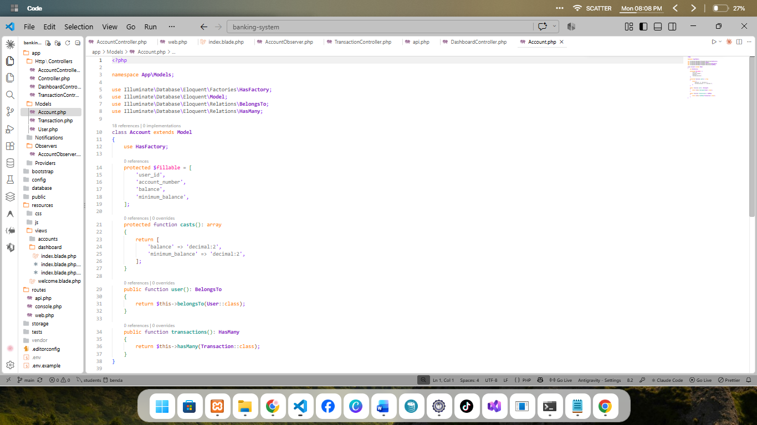
- Transaction model screenshot
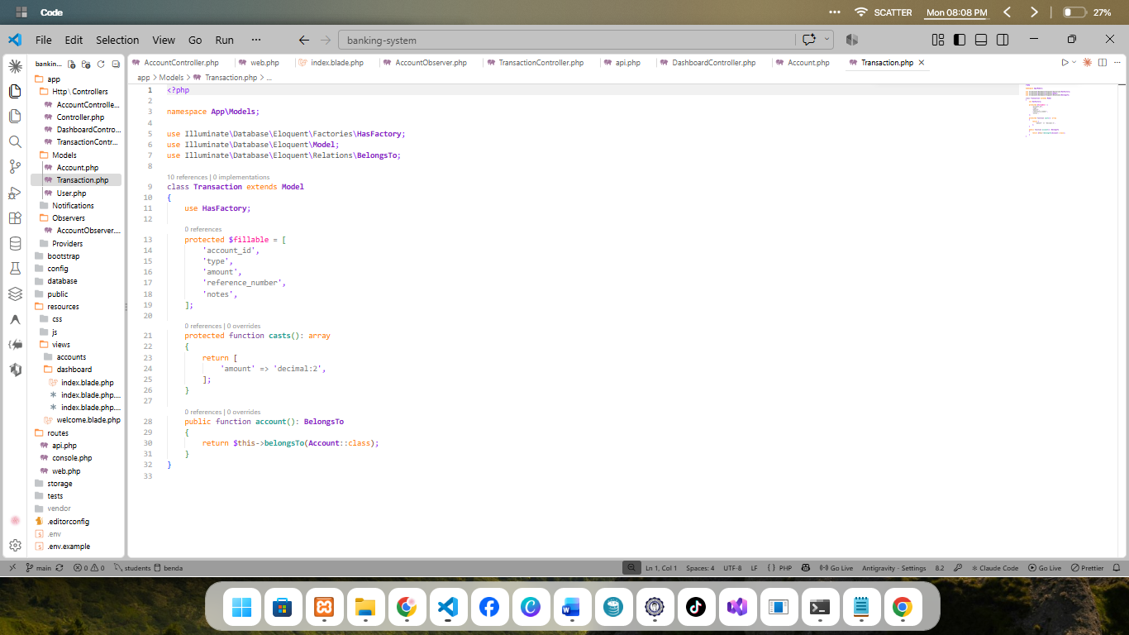
- Accounts and transactions migration screenshots
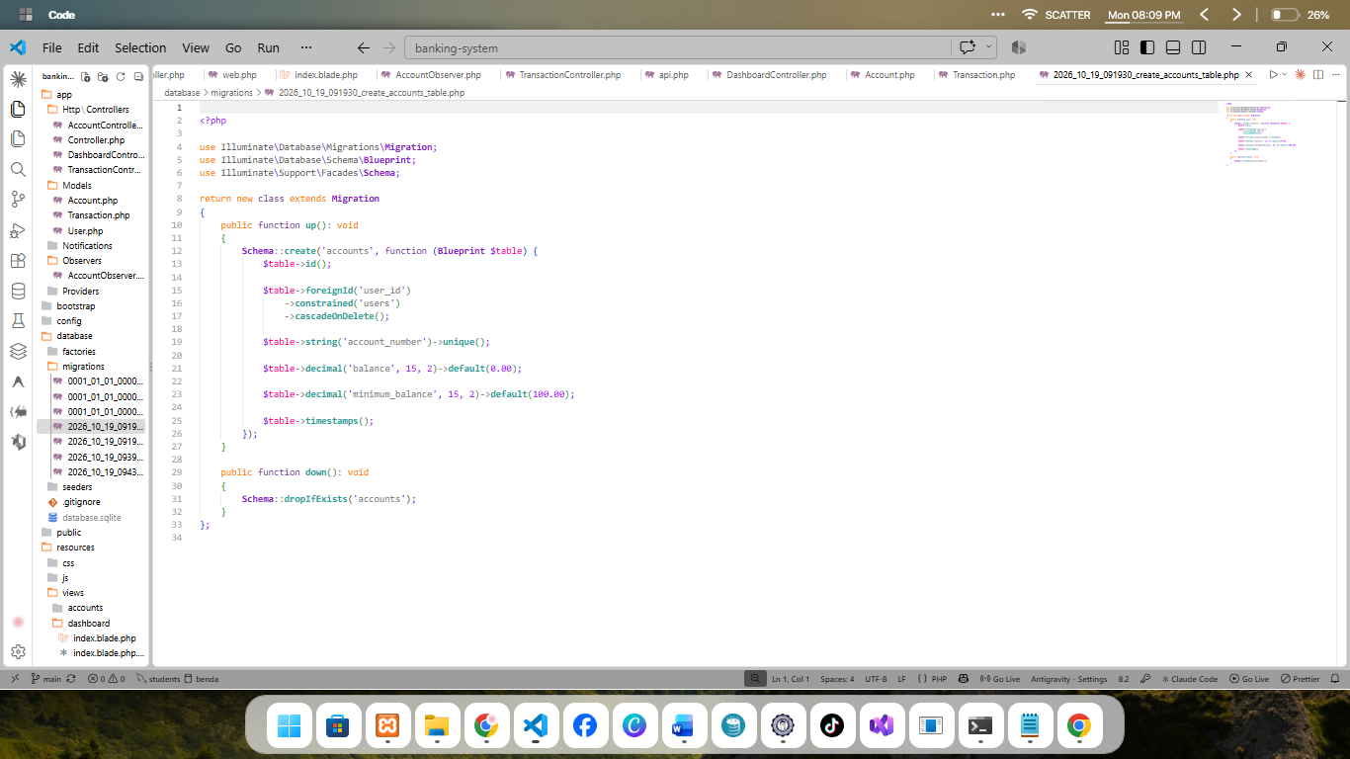
- AccountObserver screenshot
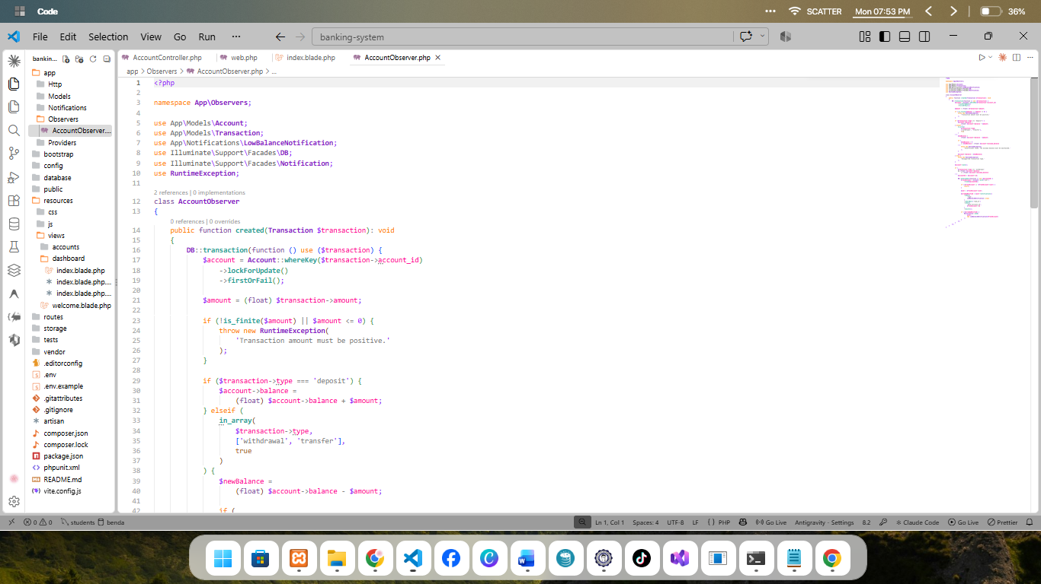

- TransactionController screenshot
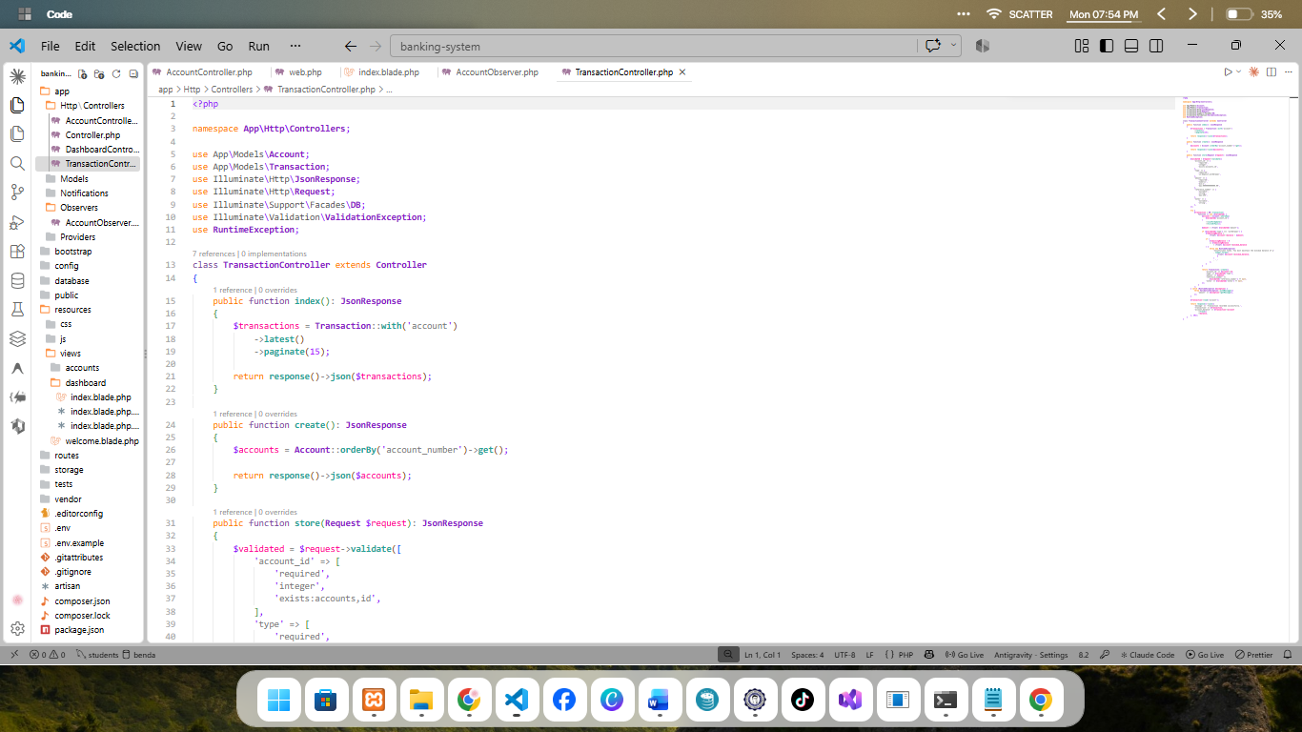
- routes/api.php screenshot
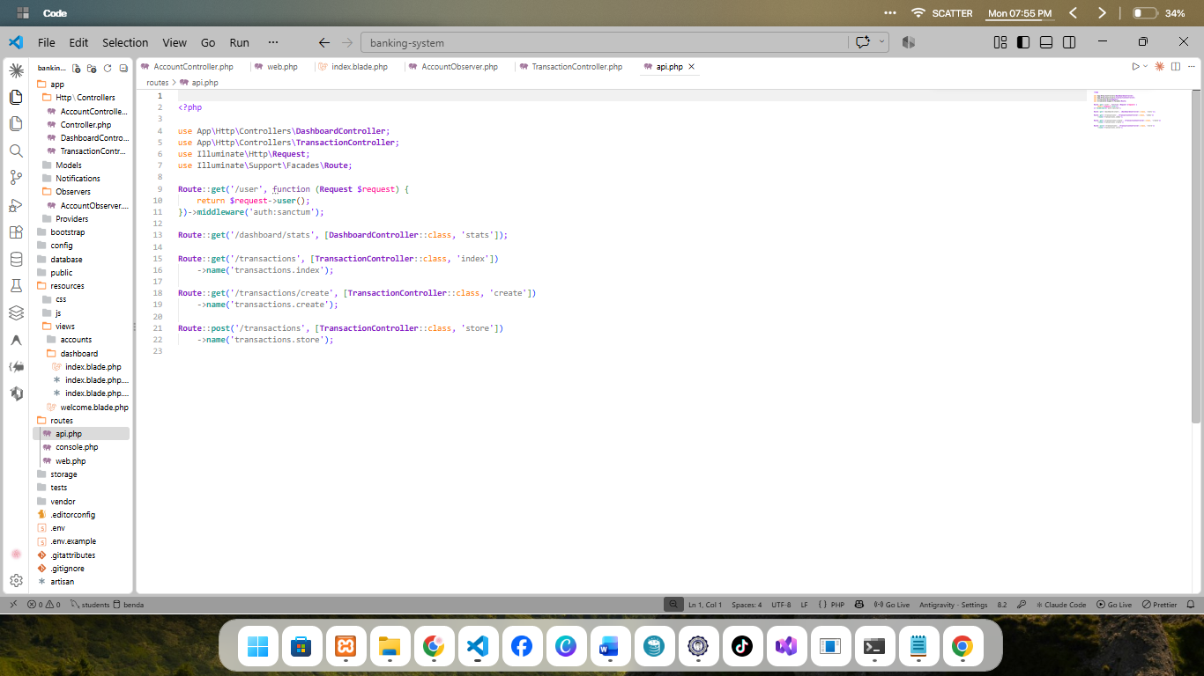
- Low-balance notification database screenshot
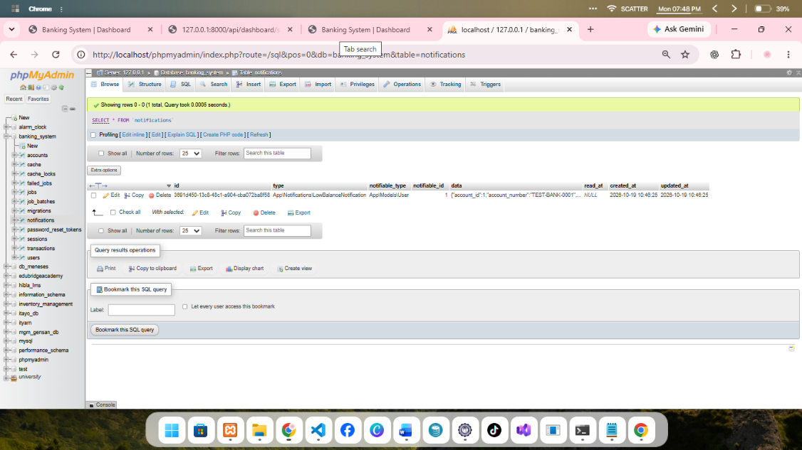

- DashboardController screenshot
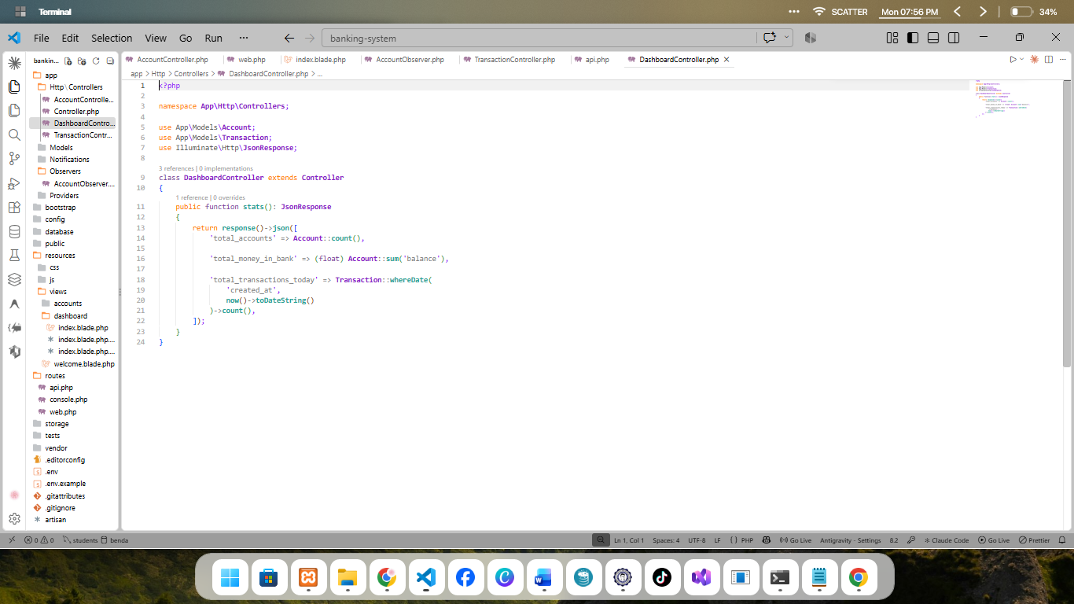
- AJAX polling JavaScript screenshot
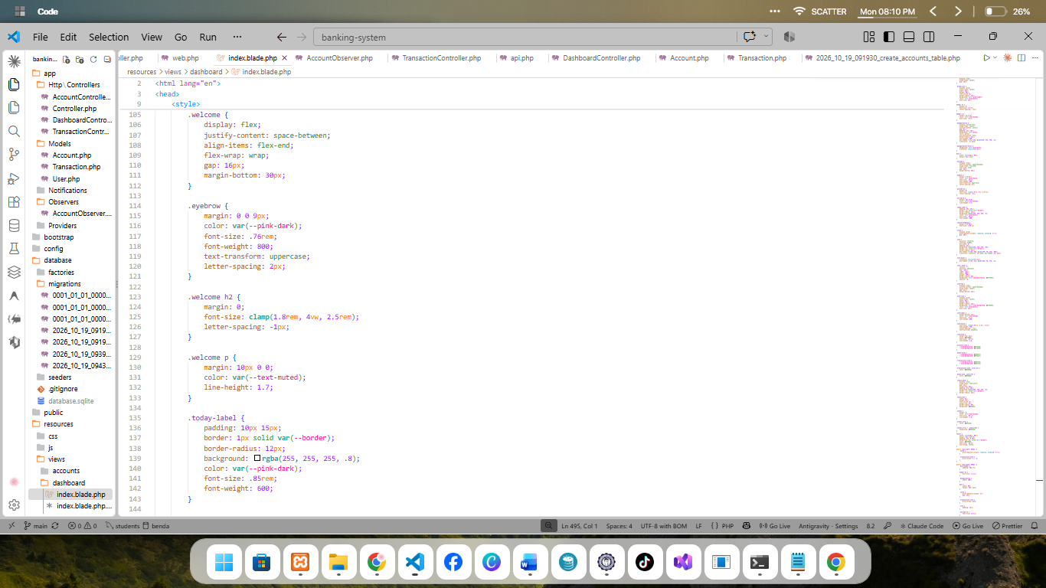
- Code committed and pushed to GitHub
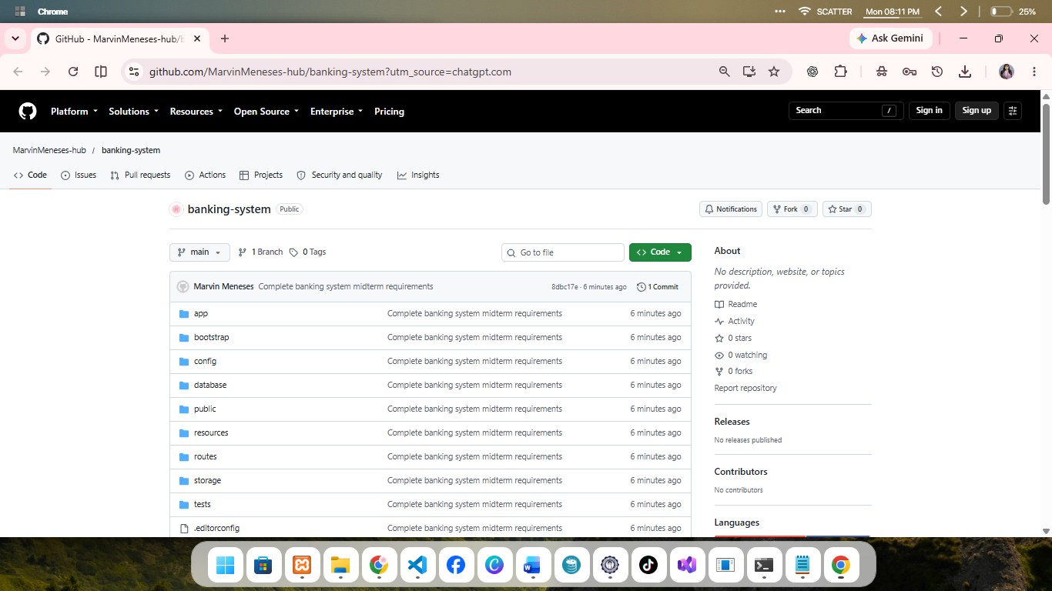

- .env excluded from GitHub
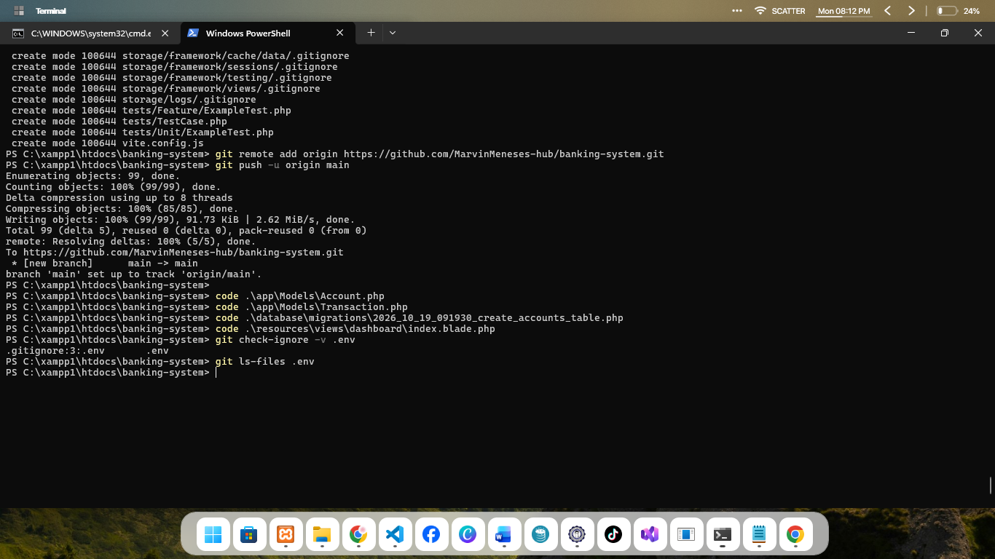

III. WRITTEN ANALYSIS
1. How does DB::transaction() help maintain data consistency during a bank transfer?
DB::transaction() helps maintain data consistency by ensuring that related database operations are completed as a single transaction. For example, when money is transferred from one account to another, the system must deduct the amount from the sender and add it to the receiver. If an error occurs during the operation, the database transaction can roll back the changes. This prevents incomplete transfers and helps keep account balances accurate.
2. What is the difference between AJAX polling and WebSockets? Why was AJAX polling used in this project?
AJAX polling and WebSockets are methods used to update information on a website. AJAX polling sends repeated requests to the server at a specific interval to check for updated information. WebSockets maintain a continuous connection between the client and server, allowing updates to be sent immediately when changes occur. In this project, AJAX polling was used to refresh dashboard statistics every 30 seconds. It is relatively simple to implement and suitable for periodically updating a dashboard, although WebSockets may be more appropriate when immediate real-time updates are required.
3. What are the advantages of using an Observer in Laravel?
A Laravel Observer helps organize application logic by responding to specific model events. In this banking system, the AccountObserver handles transaction-related balance updates and low-balance notification logic. This helps keep the controller more organized because related responsibilities can be handled separately. Observers also improve maintainability by keeping event-related logic in a dedicated class.

IV. GITHUB SUBMISSION AND VERSION CONTROL
1. Code Committed and Pushed to GitHub
The project source code was committed to the local Git repository and pushed to the remote GitHub repository using the main branch.
GitHub Repository:
https://github.com/MarvinMeneses-hub/banking-system
2. Environment File Excluded from GitHub
The .env file contains environment-specific configuration, including database connection settings. It should not be uploaded to a public repository because it may contain sensitive information. The project uses .gitignore to exclude the local environment file from Git tracking.

V. CONCLUSION
Developing the Simple Banking System helped demonstrate how Laravel components work together to build a web application. The project applies models, controllers, database migrations, API routes, and observers to organize banking operations. It also demonstrates periodic dashboard updates and low-balance notifications. Using Git and GitHub provides a way to track changes and maintain a remote copy of the project source code. Overall, this project strengthened my understanding of Laravel development, database management, and version control.

END OF REPORT

